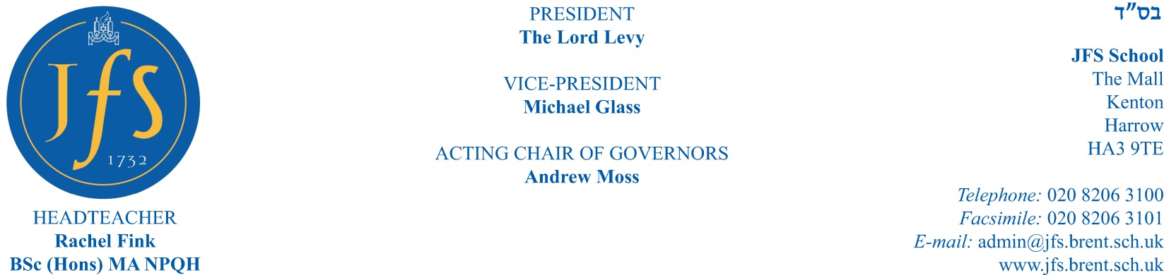
27 November 2020

Dear Parents/Carers

YEAR 11 TO YEAR 12 TRANSFER – SEPTEMBER 2021 **UPDATE**

Further to my letter of 5 November, I want to update you on the events, activities and information-sharing we are planning in order to support the choices you and your children will be making about their transfer to the Sixth Form at JFS next September. As you will understand, we are not able to welcome you to join us at school in person in the current climate.

Subject Choices

We have now published our new Pathway & Curriculum Guide 2021 detailing the outstanding academic and extracurricular provision that is offered at JFS in the Sixth Form. This is now available on the JFS website on the Sixth Form Transition page where you will also be able to find the Year 11 to Year 12 Transition Form which you can complete to indicate your son’s/daughter’s provisional subject choices. This form will need to be completed by the deadline of 1.30pm on Friday 22 January. If you make duplicate entries in this form, the most recent entry will be the one recorded by us. If you have any queries regarding this, please email Mrs Marx (Sixth Form Administrator) directly.

Sixth Form Taster Lessons

These take place at the start of the Spring Term, from Monday 11 January to Friday 22 January. This is a wonderful opportunity for your son/daughter to experience Sixth Form lessons, particularly those subjects they may not have studied previously, in order to help them make informed choices regarding their post-16 education.
Your son/daughter will need to choose four taster lessons to attend. Please complete the sign-up form here. We need you to do this by midday on Monday 7 December in order to organise the timetables. Please only make one entry per student as it will cause confusion having duplicate records. If a duplicate record does appear ONLY the original entry will be recorded. Failure to complete the form by the deadline will result in your son / daughter not being able to take part in this opportunity. If you have any queries regarding this, please email Mrs Levick (Study Room Supervisor and Post-18 Coordinator) directly.
In the meantime, I will be attending a series of virtual Year 11 assemblies to explain directly to students the process of transition into Year 12. I will be joined by subject specialist colleagues who teach subjects that your son or daughter may not have encountered previously.

Also, early in January, we will be posting a series of films about the Sixth Form. We understand that this will not replace a visit in person to the Edmond J Safra Sixth Form Centre, but we hope it will give you and your children a taste of what life is like in the Sixth Form at JFS.

Best wishes

Dr O Walton
Assistant Headteacher (Sixth Form)

