Children’s Mental Health Week 2021
As you might know by now, this week has been the 7th annual Place2Be Children’s Mental Health Week, with the theme “Express Yourself”.
This year, HRH the Duchess of Cambridge has recorded a message to mark the beginning of Children’s Mental Health week. In her message the Duchess of Cambridge talks about how important it is to express yourself and how important it is that parents look after their mental health and wellbeing too.
At JFS, children’s mental health is at the centre of everything we do, every week, but this week has been a great time for us to shine a spotlight on this.

What has JFS been doing to celebrate this week?
JFS Wellbeing Practitioners delivered individual mental health assemblies to all of KS3 and KS4, reaching over 1500 students. These looked at understanding what mental health is, checking in with ourselves, removing stigma, supporting others and finding healthy ways to express ourselves. Students were reminded of the many support systems provided in school and were given details of external agencies, including Young Minds, Childline, the Samaritans, Shout and Kooth.
We also prepared and disseminated a pack for form tutors to encourage discussion around mental health during form time and we will be running optional drop-in follow up groups next week so that we can dig a little bit deeper.
On top of this, the whole school started each day with a Pause for Thought on mental health, hearing a range of different perspectives from staff and students on what it means to express themselves.
Students were encouraged to wear an item of clothing inside out on Wednesday for the second ever Inside Out Day and to take a look at the wonderful sessions offered by the Now and Beyond Festival, focussing on a huge range of young people’s mental health issues.
We also had a great session for staff, coming together to enjoy some online fun and chat about our own mental health at this strange time.
We shared some uplifting memes for this week on our wellbeing Instagram account @jfs_wellbeing. Please do follow us if you aren’t already!

What can you do to support your children to express themselves?
- Have a chat over dinner about how your children truly express themselves and how you can support that? Maybe they draw / write / play an instrument / dance and they want to show you something they have recently done?
- Instead of asking your child how they are (and perhaps getting a one worded answer), ask them to number their day between 1 and 10. That will give you a greater idea of where they are at.
- Get creative with them! Dance around the kitchen, get the paint out, do whatever you like to get off the screens for a while and be together!
If, like many, your children struggle to always find the words, you might find this emotion wheel helpful. Look at it together and see if they can choose the word or colour closest to how they are feeling. You could even put it up at home to inspire some regular conversation on this topic!
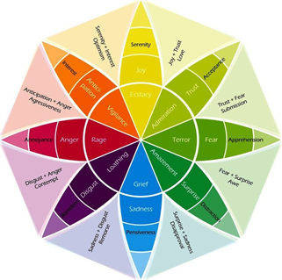

School support for young people’s mental health
The JFS wellbeing team continue to offer 1-2-1 and small group support for students during the pandemic and encourage students to reach out to us if they feel this would benefit them.
If you are worried about the mental health of your child, please contact your year team or contact us directly on the details below.
Have a great weekend,
Nicki and Nikki
cohenn@jfs.brent.sch.uk
levitan@jfs.brent.sch.uk

